**Introducing CSS3**

Cascading Style Sheets (CSS) is a style sheet language used for describing the look and formatting of a document written in a markup language.CSS3 is a latest standard of css earlier versions(CSS2).

CSS3 is the latest evolution of the *Cascading Style Sheets* language and aims at extending CSS2.1.

*It brings a lot of long-awaited novelties, like*

* rounded corners,
* shadows,
* gradients,
* Transitions or animations,

*as well as new layouts like*

* multi-columns,
* flexible box or
* grid layouts.

The main difference between css2 and css3 is follows

* Media Queries
* Namespaces
* Selectors Level 3
* Color

1. **CSS 3 History**

CSS Level 2 needed 9 years, from August 2002 to June 2011 to reach the Recommendation status. This was due to the fact that a few secondary features held back the whole specification. In order to accelerate the standardization of non-problematic features, the CSS Working Group of the W3C, in a decision referred as the Beijing doctrine, divided CSS in smaller components called *modules* . Each of these modules is now an independent part of the language and moves towards standardization at its own pace. While some modules are already W3C Recommendations, other still are early Working Drafts. New modules are also added when new needs are identified.

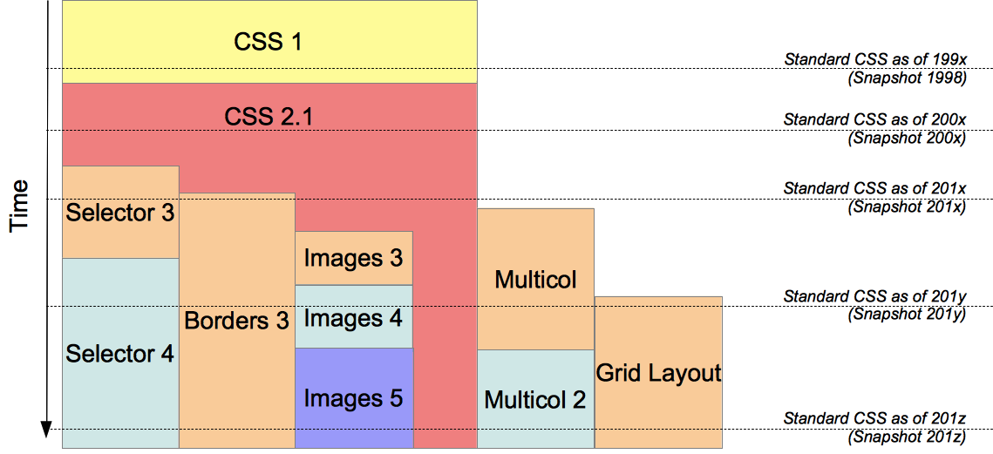Formally, there is no CSS3 standard *per se* . Each module being standardized independently, the standard CSS consists of CSS2.1 amended and extended by the completed modules, not necessary all with the same level number. At each point of time, a snapshot of the CSS standard can be defined, listing CSS2.1 and the mature modules.

The W3 consortium periodically publishes such snapshots, like in [2007](http://www.w3.org/TR/css-beijing/), [2010](http://www.w3.org/TR/css-2010/), [2015](https://www.w3.org/TR/css-2015/) and [2017](https://www.w3.org/TR/css-2017/).

Though today no module with a level greater than 3 is standardized, this will change in the future. Some modules, like Selectors 4 or CSS Borders and Backgrounds Level 4 already have an Editor's Draft, though they haven't yet reached the First Published Working Draft status.

## **2. The CSS Box Model**

All HTML elements can be considered as boxes. In CSS, the term "box model" is used when talking about design and layout.

The CSS box model is essentially a box that wraps around every HTML element. It consists of: margins, borders, padding, and the actual content. The image below illustrates the box model:



Explanation of the different parts:

* Content - The content of the box, where text and images appear
* Padding - Clears an area around the content. The padding is transparent
* Border - A border that goes around the padding and content
* Margin - Clears an area outside the border. The margin is transparent

The box model allows us to add a border around elements, and to define space between elements.

### 

### 

### 

### **Example:**

div {

width: 300px;

border: 25px solid green;

padding: 25px;

margin: 25px;

}

**Output:**

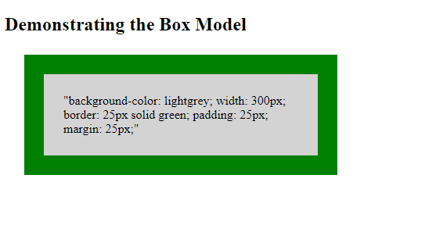

## **Width and Height of an Element**

In order to set the width and height of an element correctly in all browsers, you need to know how the box model works.

Important: When you set the width and height properties of an element with CSS, you just set the width and height of the content area. To calculate the full size of an element, you must also add padding, borders and margins.

**Assume we want to style a <div> element to have a total width of 350px:**

### **Example:**

div {

width: 320px;

padding: 10px;

border: 5px solid gray;

margin: 0;

}

**Here is the calculation:**

320px (width)

+ 20px (left + right padding)

+ 10px (left + right border)

+ 0px (left + right margin)

= 350px

**The total width of an element should be calculated like this:**

Total element width = width + left padding + right padding + left border + right border + left margin + right margin

**The total height of an element should be calculated like this:**

Total element height = height + top padding + bottom padding + top border + bottom border + top margin + bottom margin

**3. Browser Support**

### **Safari 4 (Win):**

Safari (on Windows) has by far the best feature set in the current market, outdoing competitors like Firefox 3.5 and even Google Chrome.

Particularly interesting is the excellent support for CSS3 animation properties such as CSS Transforms & CSS Animations, which enable the developer to define javascript-like rotation, movement and easing via CSS ([advanced demos](http://www.the-art-of-web.com/css/css-animation/)).HTML5 features are well supported with Canvas, Video and Audio all implemented. Only the Geolocation API is currently not available, although apparently this is in the pipeline.

### 

### **Firefox 3.5 (Win):**

Firefox 3.5 has good support for features that you might be looking to use in your client work on a day-to-day basis. @font-face, box-shadow, rgba() and border-radius all work nicely.

Although, it doesn't quite match up to Safari when it comes to CSS animation, it makes up for this with solid [implementation of HTML5 media](https://developer.mozilla.org/En/Using_audio_and_video_in_Firefox) (video and audio).

A major plus is that Firefox 3.5+ implements the first public draft of the Geolocation specification from the W3C which I anticipate will be very useful in future web applications.​

### 

### 

### 

### **Google Chrome (Win):**

As you'd expect for a WebKit browser, Chrome has really excellent support for almost all of the Modernizr tests generated by findmebyip.com.

The big let down is the lack of support for @font-face. This has been [widely documented](http://paulirish.com/2009/chrome-and-font-face-a-summary/) and there are known work arounds for it. Google has promised that the next version of Chrome will add native support for web fonts.

I was very surprised to see 3D Transforms return positive. I believe this is currently only supported by the iPhone and iPod Touch so I'm not sure about the accuracy of this result.

### 

### **Opera 10 (Win):**

We got quite a [few comments](http://twitter.com/ackernaut#status_4836262442) about Opera's perceived lack of support for advanced features. It's true that support for CSS3 features is poor, especially when border-radius still hasn't been implemented.

Nevertheless, as [Bruce Lawson has suggested to me](http://www.deepbluesky.com/blog/-/findmebyip-com-our-latest-afternoon-project_71/#comment_123), Opera does have good support for other important web standards which are currently not being tested by findmebyip.com. He highlights "Web Forms 2" and [SVG support](http://www.w3.org/Graphics/SVG/Test/20061213/htmlObjectHarness/full-animate-elem-04-t.html) as two primary examples of Opera's excellence in these areas.Nonetheless, I still feel that Opera needs to catch up with the CSS3 spec if it wants to be adopted by the mainstream web dev community.

### 

### 

### 

### **Internet Explorer 6, 7 & 8:**

And now the one you've all been waiting for. Lets all have a good laugh! Well not quite, because unlike some other contenders, Internet Explorer does actually support @font-face (all be it only in .eot format). In fact it's supported it for a while, with even IE6 providing complete support!

Nonetheless, with the exception of font-face, Internet Explorer does display a marked lack of support for almost every kind of advanced/progressive feature. Hopefully the IE team will be able to look at this in a future release, but I'm not holding out any hope.

### 

### **Summary:**

There is now a consistent level of support for many of the CSS3 and HTML5 features that the average developer might use for progressive enhancement. From my survey the most widely supported features were:

* rgba()
* hsla()
* opacity()
* border-radius (except Opera)
* canvas

Outside of these however, support is patchy and is largely dependant on the whim of the browser manufacturer. Some browsers are way ahead of the game (Safari), whilst others have a intermediate (Firefox) or even poor(?) support (Opera).It should be noted however, that findmebyip is not perfect and as a result doesn't report on all advanced features. We'll be upgrading the site in the near future to include a full range of tests for Web Forms and even SVG graphics, so perhaps another test will be in order then.Finally a request to you Mac geeks out there. Unfortunately, we don't run Mac's so I can't comment on OSX versions of these browsers. If anyone would like to let us know how the Mac versions of these browsers perform and post them as a comment we'd be very grateful.

**To get a clear browser support for every CSS3 Module. Use the following links:**

1. <https://css3clickchart.com/?prop=box-sizing>;
2. https://www.w3schools.com/cssref/css3_browsersupport.asp

**REFERENCES**

1. **https://developer.mozilla.org/en-US/docs/Web/CSS/CSS3**
2. **https://www.tutorialspoint.com/css/css3_tutorial.htm**
3. **https://css3clickchart.com/?prop=box-sizing;**
4. **https://www.w3schools.com/cssref/css3_browsersupport.asp**